**QLIK SENSE ASSIGNMENT**

****Assignment - 1****

Please see below the Qlik Sense assignment on Survey Response and Sales Analysis using from AdventureWorks.

* KPIs to show gender wise # of responses.
* Table to show # of Customer based on their First Purchase Date.
* Pie Chart's show # of Product by Marital Status.
* Bar Chart to show # of Product by month year.
* Bar Chart to show # of Product by Age Range <16, 16-25, 26-40, >40.

**DATA LOAD EDITOR:**

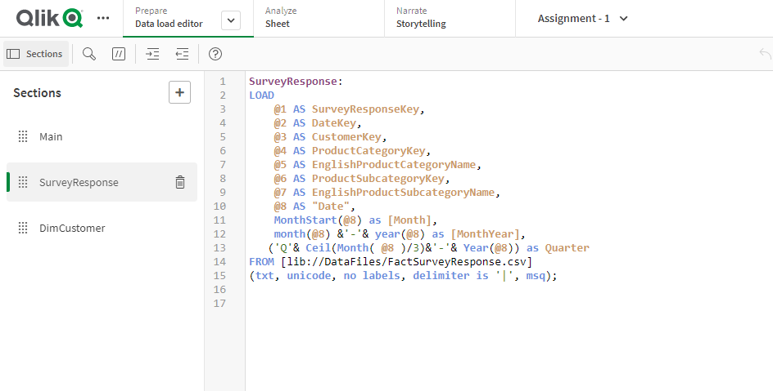

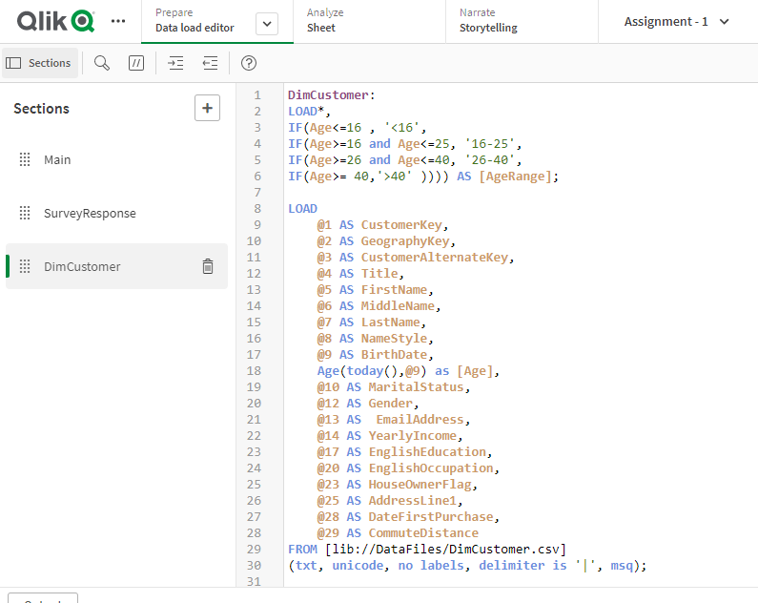**DATA MODEL VIEWER:**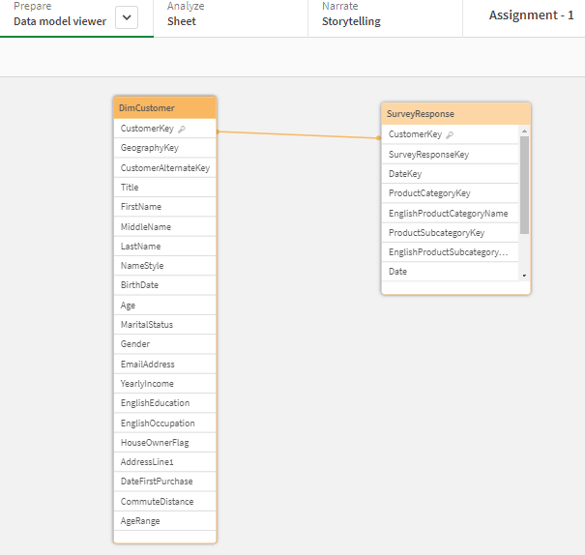

**Dashboard:**

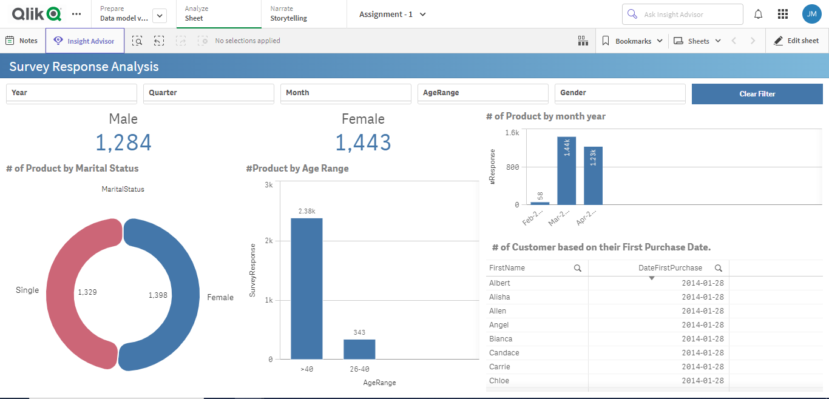

****Assignment - 2****

**Sheet - 1:**

* Bar Chart to show the Sales Amount Quota by Year and on selection of year show the same chart by Quarter and then by Month when the Quarter is selected.
* Bar Chart to show the Sales Amount Quota by Employee's Department and option to see the same by Employee.
* Pie Chart to show the Sales Amount Quota by Employee's Age Range (buckets <=30, 31-40, 41-50, >50).
* Add filters like Year, Quarter, Month etc.
* Have '2003' year as a default selection for the particular sheet.

**Data Load editor:**

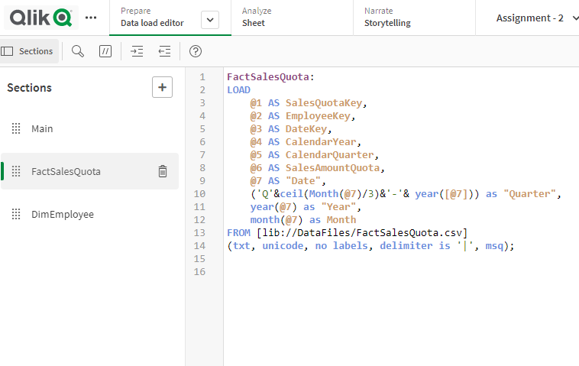

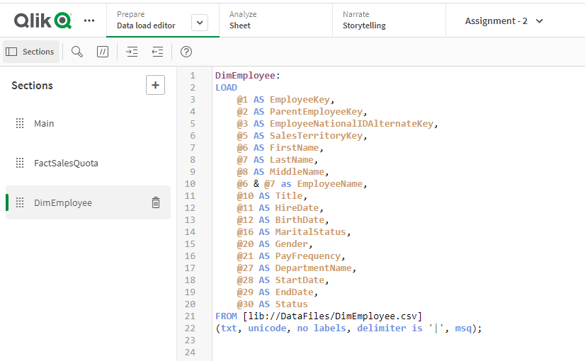

**Data Model Viewer:**

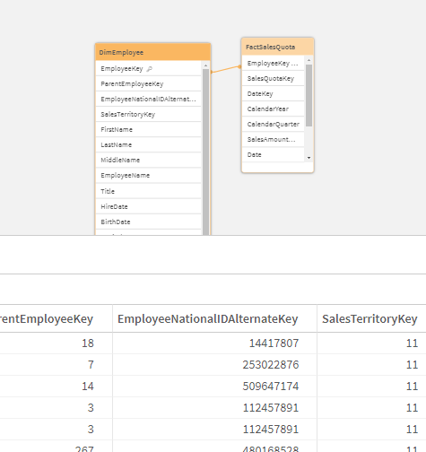

**Dashboard:**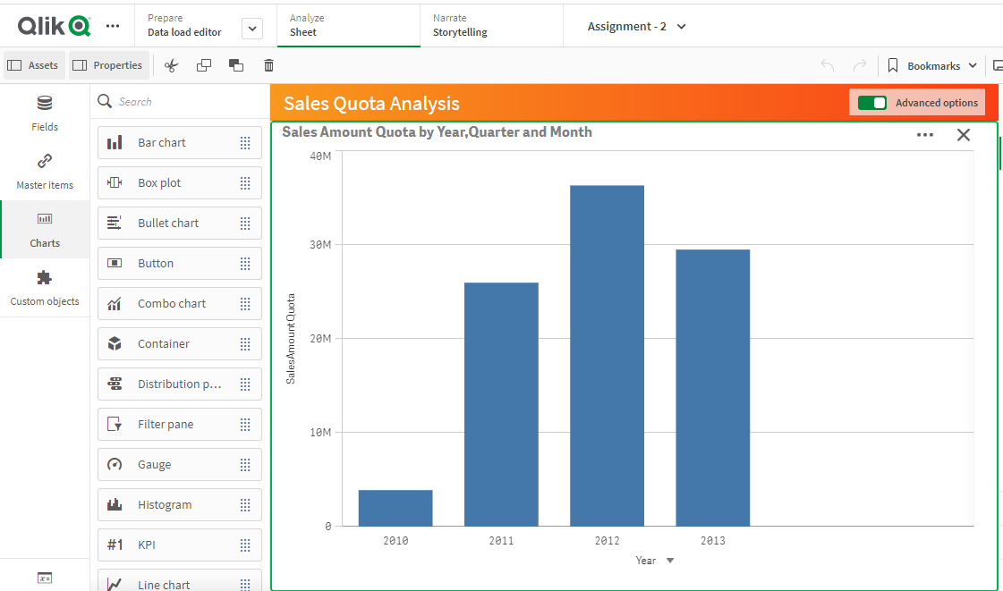

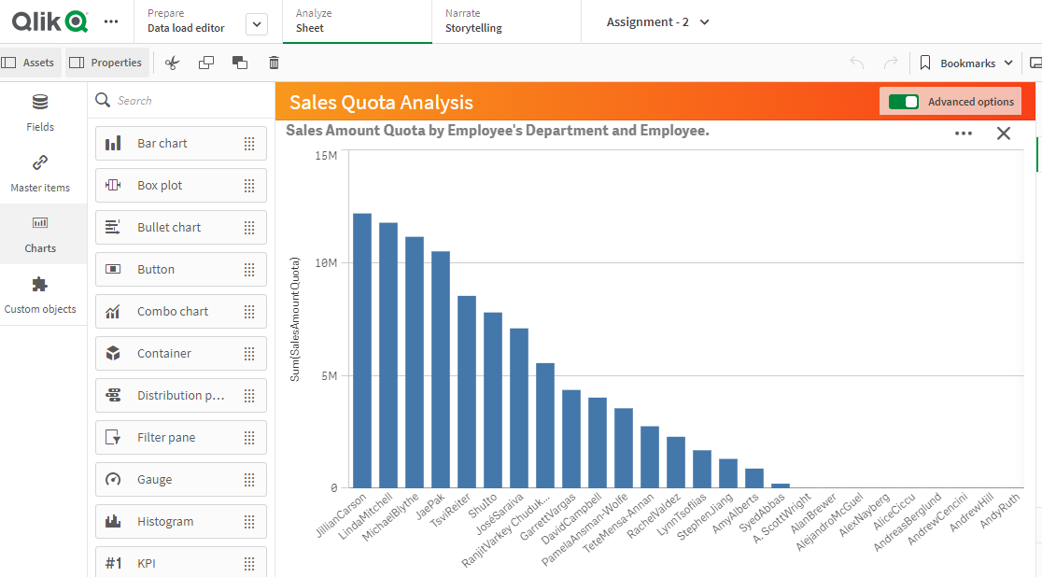

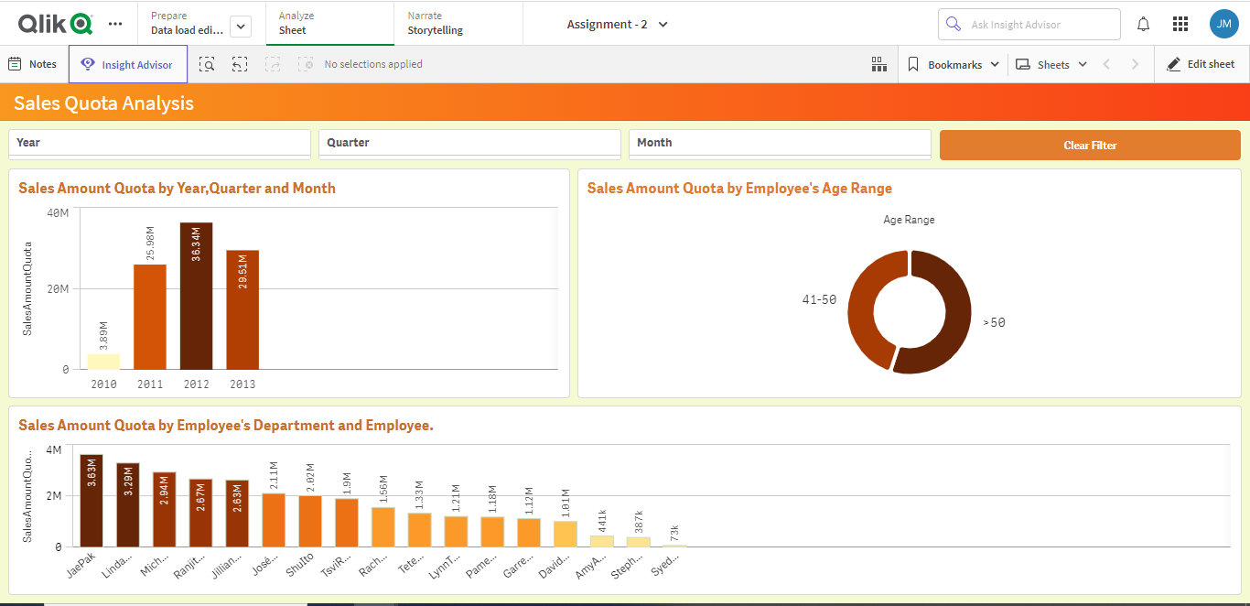

**Sheet:2**

* Table to show the Employee details with the following information:  
  First Name, Last Name, Gender (Male/Female), Hire Date, Department, Sales Territory Region, Vacation Hours, Paid off time (Vacation Hours * Base Rate).
* Pivot Table to show the Sales Amount Quota by Parent Employee and on expand the same show the data by second level employee's - choice to show by Year/Quarter/Month.
* Heat map chart to show Sales Amount Quota by Sales Territory Region.
* Map to show Sales Quota Amount by Sales Territory Country.
* Have the Filters that you have in Sheet - 1.

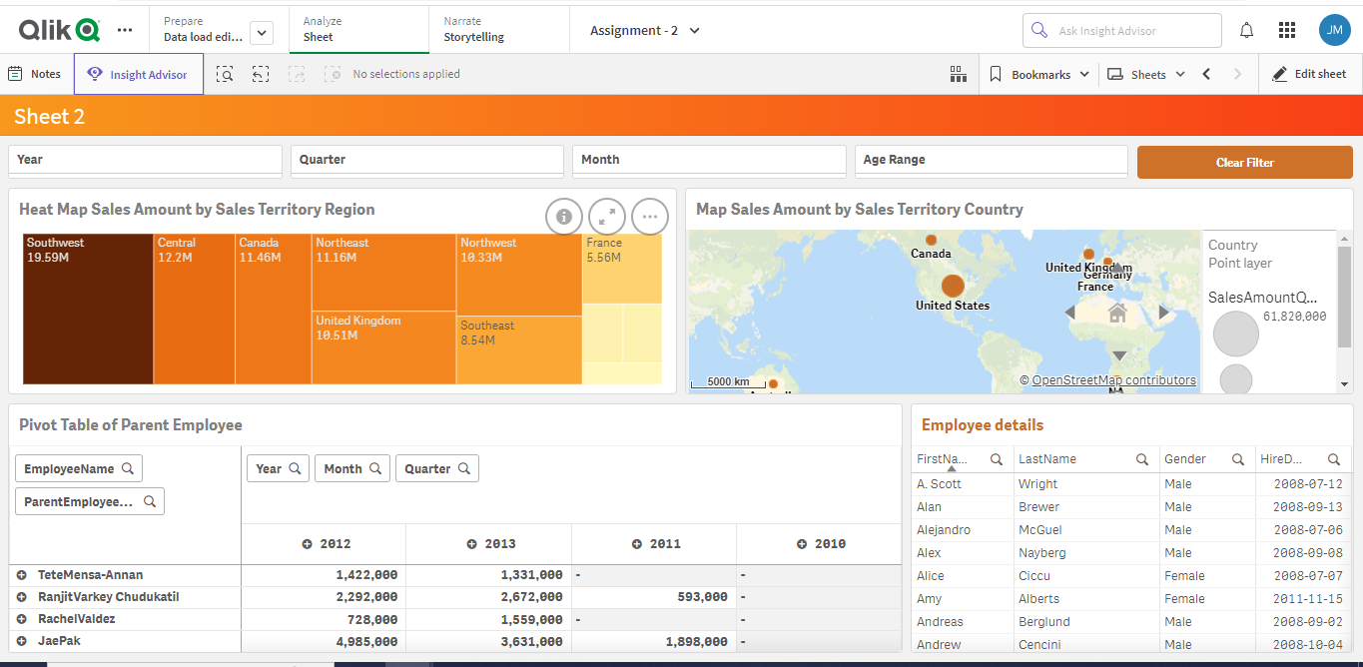

**Assignment - 3**

* KPI's to show Actual, Budget, Forecast and Variance (Difference between Actual and Budget) by Quarter, Month, and Year.
* Bar chart to show Actual, Budget, Forecast on the selection of scenario for Year, Month, and Quarter a drop down to select the time period.
* Pie chart to show Actual, Budget, Forecast on the selection of scenario for Department  and for the time period.
* Bar chart to show Actual, Budget, Forecast for region.
* Pie chart to show Actual, Budget, Forecast for Organization.
* Pivot Table to show the Actual, Budget, Forecast by Parent Account and on expand the same show the data by Account type - choice to show by Year/Quarter/Month.
* Have filters of your choice and split the charts to two sheets.

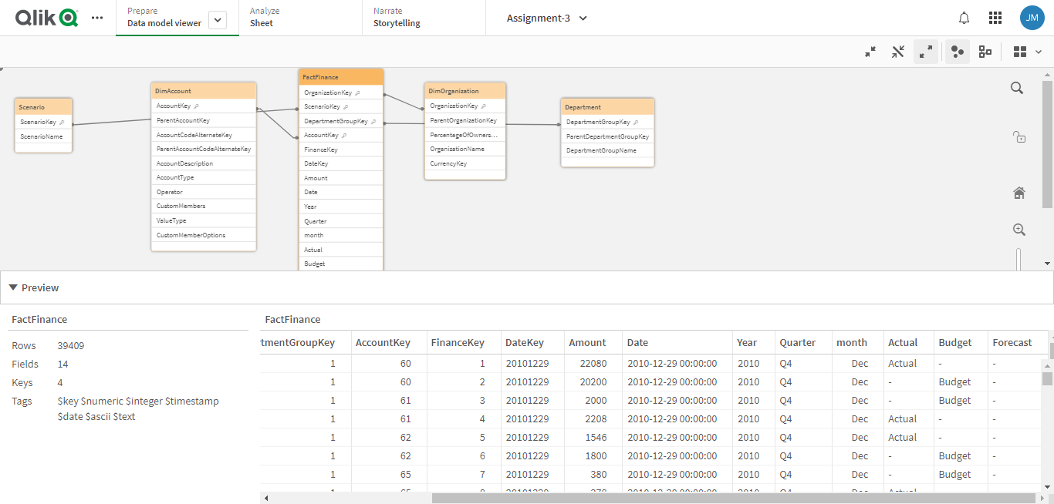

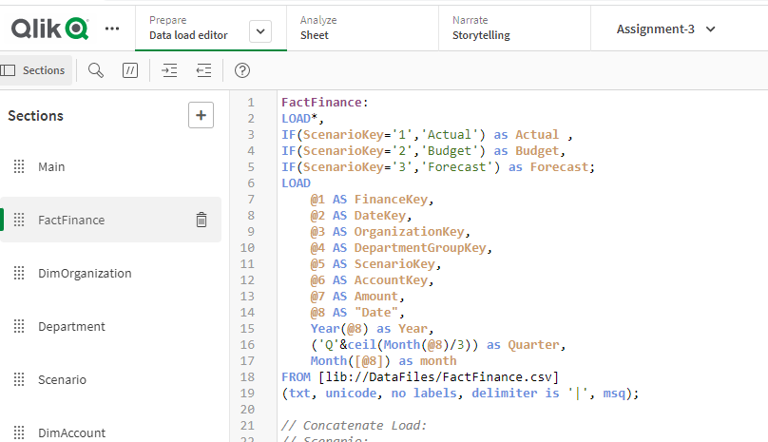

**Dashboard:**

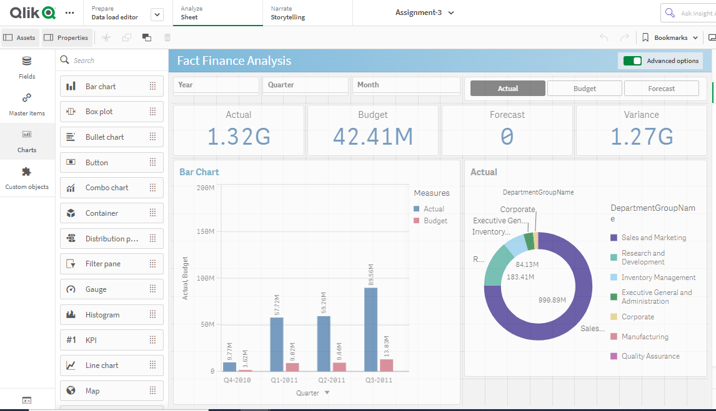

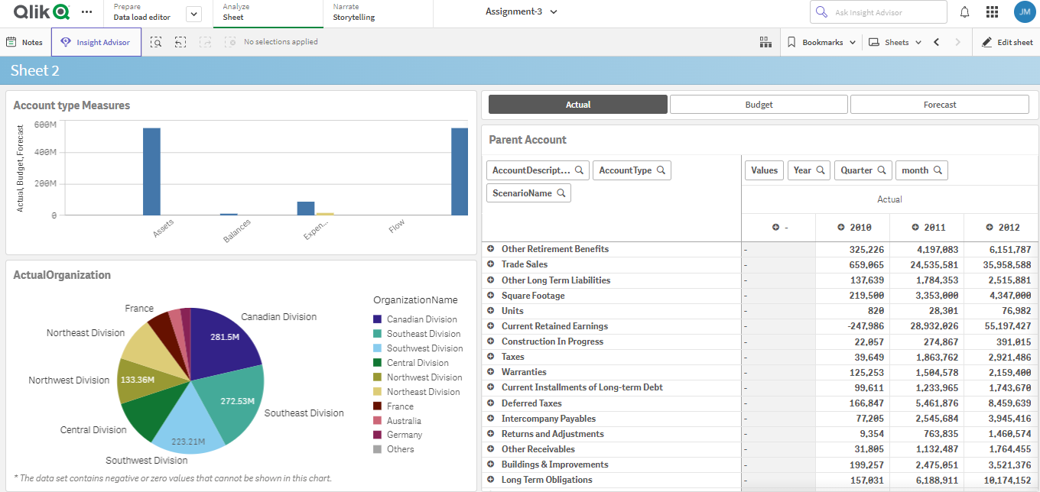

**Assignment - 4**

Please see below another assignment,

* KPI's to show current year, current month, current quarter, Sales Amount and Quantity have a option to choose.
* Bar Chart to show Sales Amount and Quantity by Product and Product Group.
* Bar Chart to show Sales Amount and Quantity by Sales Rep.
* Pie Chart to show Sales Amount and Quantity by Region.
* Pie Chart to show Sales Amount and Quantity by Sales Customer.
* Table to show Employee and Customer details have a button to choose.
* Have filters of your choice.
* Have a Button to Clear all the selections.

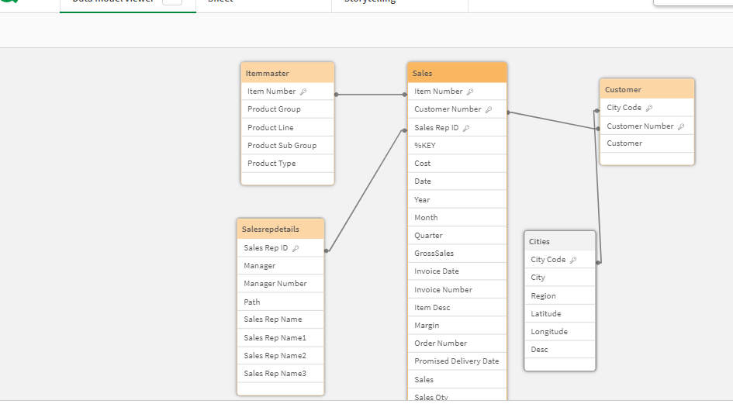

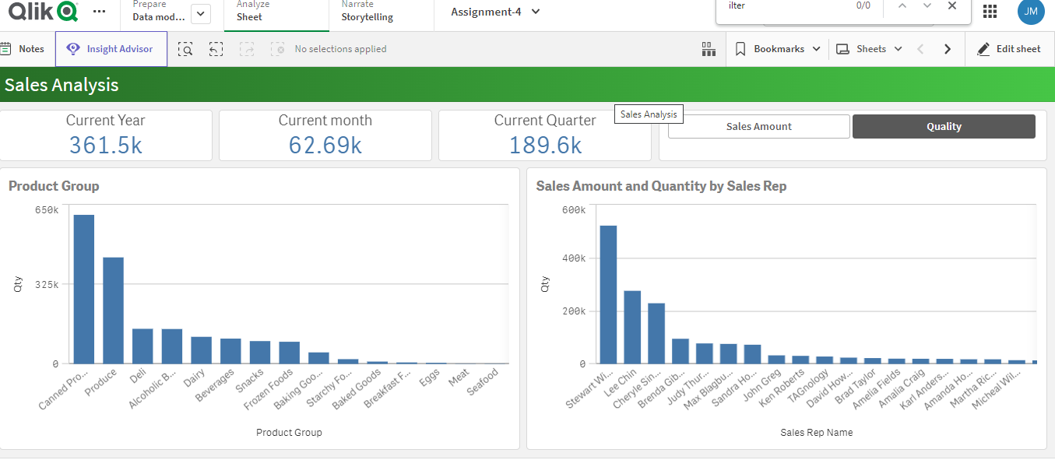

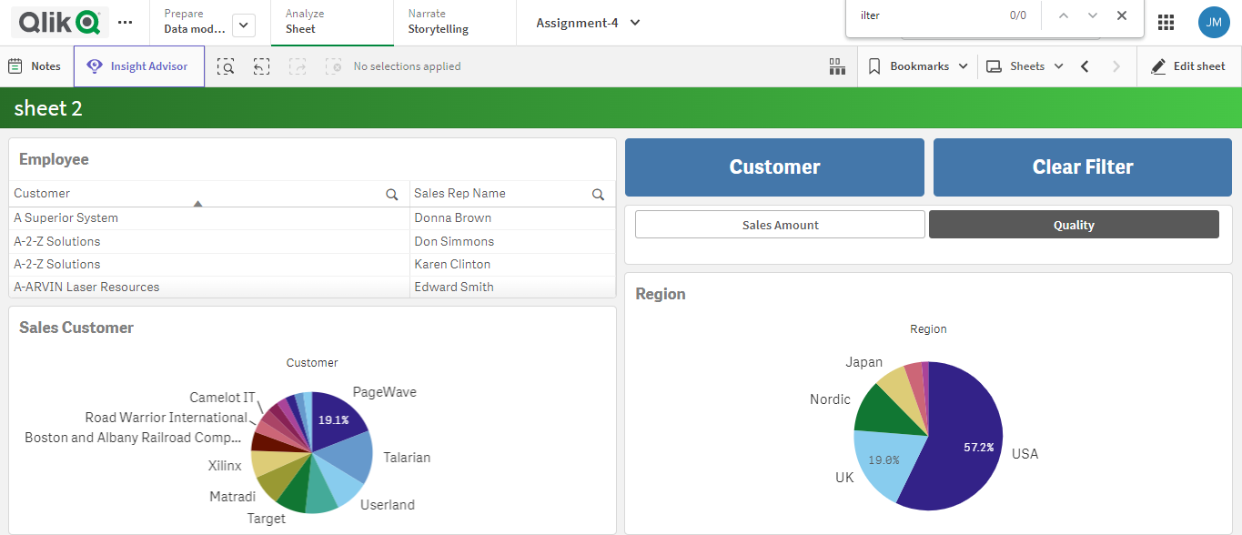

**Assignment - 5**

Please see below the Qlik Sense assignment,

* **KPI's** to show Total order quantity, current year order quantity and for previous year.
* Chart to show Top five Ordered Products.
* Chart to show Ordered Products by year.
* Chart to show Ordered Products by Month.
* Pie chart to show Ordered Quantity by country.
* Pie chart to show Ordered Quantity by product category.
* Table to show Ordered details.
* Have Filters of your own.